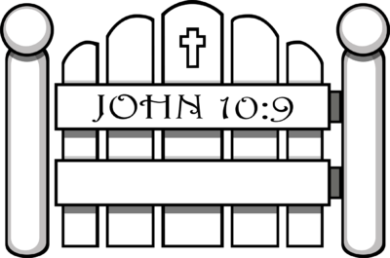

Jesus said, “I am the gate;
whoever enters through me will be
saved.”

Fourth Sunday of Easter
April 30, 2023

Welcome! We are glad you are here! In worship, we gather before the almighty God to offer him the praise that is due his name and to be fed by his life-giving Word. This service folder will guide you through our path of worship. If you have any questions, please don’t hesitate to ask an usher or the person sitting next to you. God bless your time in this house of God.

Bathrooms are located in the fellowship hall. A changing table is located in the women’s bathroom.

A worship monitor is to the right as you exit. We encourage children of all ages to participate in our worship. Please bring them into the service. We have a nursery room with toys, books, and other items that you can use with your child.
Before you leave, please sign our guest register. Located on the lectern in the entryway.

OPENING HYMN Today Your Mercy Calls Us (CW 339)

M: We begin our praise and worship the same way we were baptized: In the name of the Father and of the Son and of the Holy Spirit.
C: Amen.
Confession and Absolution
(Congregational response sung to tune of “Beautiful Savior”)

M: We draw near to you, O God, because you are willing to forgive. We come to you in repentance and faith, and we cry out for mercy.
C: ♫ Father, I've failed You.
See my sin and selfishness;
See how I've nourished my foolish pride.
Touch with Your mercy;
Speak Your forgiveness
Through all the guilt I've tried to hide.

M: Almighty God, our heavenly Father, has had mercy upon us and has sent his Son to be the atoning sacrifice for all our sins.
C: ♫ Jesus, my brother,
Human, Holy Savior,
You feel the weakness I feel within.
You are my Righteousness;
You are my Confidence,
For when I'm weak, Your strength begins.
M: As a called servant of the Word, I announce the grace of God to you, and in the stead and by the command of my Lord Jesus Christ, I forgive you all your sins in the name of the Father and of the Son and of the Holy Spirit. May he who began this good work in you bring it to completion on the day of our Lord, Jesus Christ! Amen.
C: ♫ Moment by moment,
Marvelous, Almighty God,
Resting in You, I am truly free.
Teach me to trust You;
Teach me to walk in You,
My Lord, my Strength, my Liberty!

Prayer and Praise
In the peace of forgiveness, let us praise the Lord.
OH, TASTE AND SEE

C: Oh, taste and see that the Lord is good. Blessed are they who take refuge in him. Your Word, O Lord, is eternal; it stands firm in the heavens. Your faithfulness continues forever. Oh, taste and see that the Lord is good. Blessed are they who take refuge in him.

PRAYER OF THE DAY
M: O Lord Jesus Christ, you are the Good Shepherd who laid down your life for the sheep. Lead us now to the still waters of your life-giving Word that we may abide in your Father’s house forevermore; for you live and reign with him and the Holy Spirit, one God, now and forever.

C: Amen.

The Word

FIRST LESSON Acts 2:42-47

PSALM OF THE DAY Psalm 23 (CW pg. 72)

SECOND LESSON 1 Peter 2:19-25

GOSPEL ACCLAMATION
M: Alleluia. I am the good shepherd; I know my sheep and my sheep know me. Alleluia.
SEASONAL RESPONSE

“Chief of Sinners Though I Be”

C: Chief of sinners though I be,
Jesus shed his blood for me,
Died that I might live on high,
Lives that I might never die.
As the branch is to the vine,
I am his and he is mine!

Oh, the height of Jesus’ love,
Higher than the heav’ns above,
Deeper than the depths of sea,
Lasting as eternity,
Love that found me – wondrous thought!
Found me when I sought him not.
GOSPEL John 10:1-10
M: This is the Gospel of the Lord.
C: Praise be to you, O Christ!

HYMN OF THE DAY The King of Love My Shepherd Is (CW 375)

SERMON

APOSTLES CREED

M: In a world that has difficulty believing in the one true God, but
is so ready to believe that our universe happened by some unknown accident, what do you believe?
C: I believe in God, the Father almighty, maker of heaven and earth.
M: In a society that so quickly rejects what God did through His Son, what do you believe?
C: I believe in Jesus Christ, His only Son, our Lord, who was conceived by the Holy Spirit, born of the virgin Mary, suffered under Pontius Pilate, was crucified, died, and was buried.
M: While many put their trust in things or people that they make into their gods, what do you believe that Jesus did that proves He has conquered death and is true God just as He said?
C: He descended into hell. The third day he rose again from the dead. He ascended into heaven and is seated at the right hand of God the Father almighty. From there He will come to judge the living and the dead.
M: Those who refuse to trust the Lord are without hope. What do you believe that gives you hope?
C: I believe in the Holy Spirit, the holy Christian Church, the communion of saints, the forgiveness of sins, the resurrection of the body, and the life everlasting. Amen.

OFFERING We joyfully respond to our Shepherd’s loving care by praising him with all we are and all we have. Bringing an offering is an act of trust in God’s promises to provide and an acknowledgement that “my cup overflows.” A joyful and generous offering is always a wonderful way to show Jesus that he is our greatest treasure and worthy of our praise. May God be praised through our offerings!

PRAYER OF THE CHURCH
M: Jesus, Good Shepherd and Gate for your sheep, continue to give us life, that we may enjoy it to the full.
Lord our Shepherd, in you we lack nothing.
C: We will fear no evil, for you are with us.

M: We all, like sheep, have gone astray, but you have borne the iniquity of us all by laying down your life. Teach us to know your voice, that we may follow you closely, enter your gate and be saved.
Lord our Shepherd, in you we lack nothing.
C: We will fear no evil, for you are with us.

M: Open the gate of your fold to other sheep. Call them also to be fed in the green pastures of your Word and refreshed with the quiet waters of your baptismal grace.
Lord our Shepherd, in you we lack nothing.
C: We will fear no evil, for you are with us.

M: Bless the gatekeepers who shepherd your people with you, those who teach the young, who lead your people in worship and praise, and those who minister to the aged, sick and dying. Strengthen them with the love of your people, and through their work add to the number of those who are being saved.
Lord our Shepherd, in you we lack nothing.
C: We will fear no evil, for you are with us.

M: Shepherd and Overseer of souls, return the wandering, the lost, and the doubting to you. Restore their souls and guide them again to your right paths.
Lord our Shepherd, in you we lack nothing.
C: We will fear no evil, for you are with us.

M: With the compassion of a Shepherd, walk with those who go through the darkest valleys of life, sickness, despair, and even the shadow of death. [We ask your special blessing for …]. With your Word, remind them of your presence and take away their fears.
Lord our Shepherd, in you we lack nothing.
C: We will fear no evil, for you are with us.

Special prayers and intercessions may follow.

M: Listen, Lord, to the thoughts and cares of our hearts.

Silent prayer

M: Lord our Shepherd, in your kindness you give us all good things. Fill us with your overflowing cup, and bring us to dwell with you in your house, where you live and reign, now and forever.

C: Amen.

LORD’S PRAYER

C: Our Father, who art in heaven, hallowed be thy name, thy kingdom come, thy will be done on earth as it is in heaven. Give us this day our daily bread; and forgive us our trespasses, as we forgive those who trespass against us; and lead us not into temptation, but deliver us from evil. For thine is the kingdom and the power and the glory forever and ever. Amen.

HYMN OF THE DAY Jesus, Shepherd of the Sheep (CW 436)

M: Blessed Lord, you have given us your Holy Scriptures for our learning. May we so hear them, read, learn, and take them to heart, that being strengthened and comforted by your holy Word, we may cling to the blessed hope of everlasting life, through Jesus Christ, our Lord, who lives and reigns with you and the Holy Spirit, one God, now and forever.

C: Amen.

BLESSING

M: Brothers and sisters, go in peace. Live in harmony with one another. Serve the Lord with gladness.
The Lord bless you and keep you.
The Lord make his face shine on you and be gracious to you.
The Lord look upon you with favor and give you peace.
C: Amen. Amen. Amen.

CLOSING HYMN Spread, Oh, Spread the Mighty Word (CW 576)

Come worship with us again!
Next Sunday, May 7TH - 2:00 pm

VACANCY PASTOR

Christopher Hoppe, Pastor stjohnluthvaca@outlook.com
(920) 652-4003 www.stjohnvacaville.org
christopherhpp@gmail.com

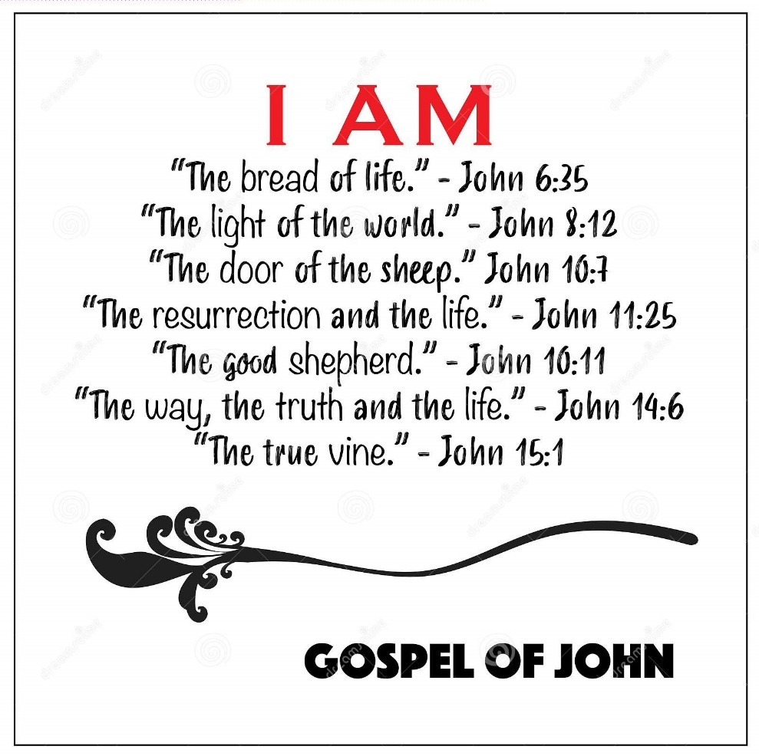

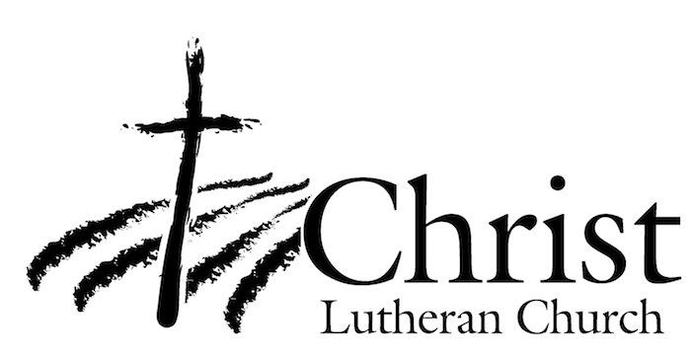
13009 N. Elderberry Ct.
Lodi, CA 95242
www.christlodi.org
209-368-6250
WELCOME TO CHRIST EV. LUTHERAN CHURCH!
We preach a message of forgiveness, hope and peace
through the death and resurrection of Jesus Christ.
Families and individuals of all ages will find opportunities
both to grow and to serve.

Our mission statement:
Look what Christ is doing!
He binds us together in fellowship
He gathers us in for worship
He builds us up for service
He sends us out with the gospel

“Now you are the body of Christ,
and each one of you is a part of it.”
(1 Corinthians 12:27)

